**Nama : Auveta Rizky Pratama**

**NIM : 1202220295**

**Kelas : SI-46-06**

**No.2**

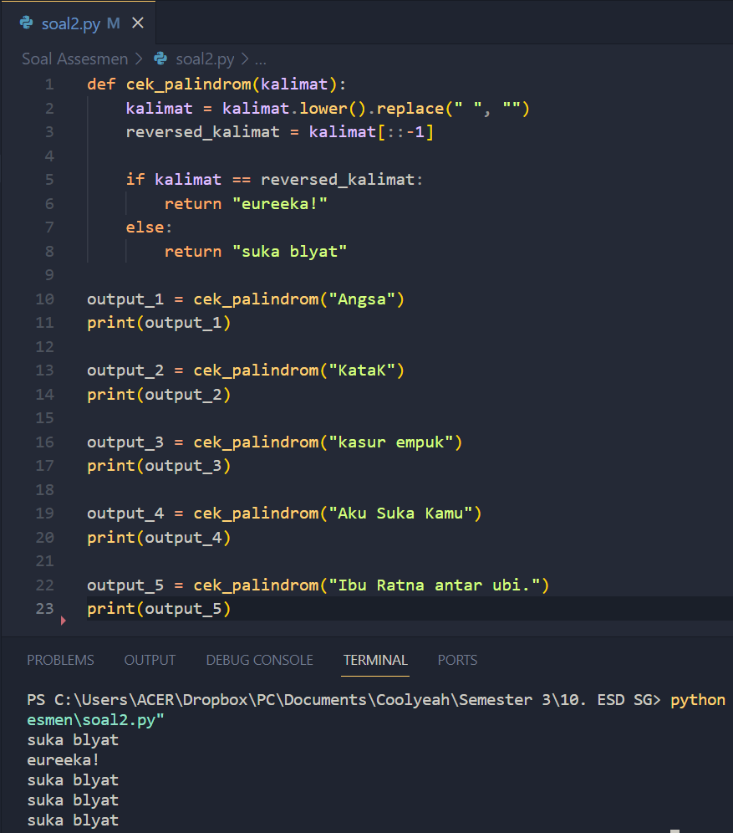

**No.3**

